TO: Mayor Linda Gorton
Honorable Members, Urban County Council
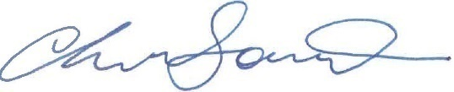

FROM: _____________________________________
Chris Ford, Commissioner of General Services

DATE: December 31, 2024

SUBJECT: Music License Agreement with AllTrack Performing Rights, LLC

Request:
Request Council Authorization for the Mayor to enter into a music license agreement between LFUCG and AllTrack Performing Rights, LLC.

Purpose:
This license agreement provides to LFUCG a non-exclusive right to play, in whole or in part, musical compositions granted by the license, as part of public performance events sponsored, promoted or conducted by LFUCG programs and / or agencies. Agreement will automatically renew annually unless either party provides a written letter of termination prior to 30 days of the agreement term. This is a new music catalog vendor that is used primarily by Division of Parks & Recreation and GTV3 will use for various songs and/or musical artists.

Budgetary Implication:
Cost for the current fiscal year: $3,179.00

Are the funds budgeted?

Yes, 1101-707101-0001-71216

File Number: 0035-25

Director/Commissioner: Chris Ford

